GUIDE TO MAKE STRATMAPS WITH STRATOOL
By DAK_Legion
First…Download this as it will add to this guide…
http://www.closecombatseries.net/CCS/modules.php?name=Downloads&op=getit&lid=600
http://www.closecombatseries.net/CCS/modules.php?name=Downloads&op=getit&lid=2015
After extracting the .zip
Read the readme files for each tool for instructions. (They should be easy to understand)
You need to create the following images in .tga format as it says in the readme for the Stratool:
graph.tga the main stratmap image 1708x1129 pixels, see NORMANDY in CCImages.pix
mask.tga main stratmap mask 1708x1129 pixels
dgraph.tga debrief map image 559x348 pixels, see DBCAMPAIGNMAP in ScrnGadg.gdg
dmask.tga debrief mask 559x348 pixels
usDebrief.tga the image for US controlled areas 560x348 pixels
bothDebrief.tga the image for contested areas 560x348 pixels
geDebrief.tga the image for GE controlled areas 560x348 pixels
eGraph.tga the scenarioeditor screen, 800x600 SCENARIOEDITORSCREEN in CCImages.pix
For graph.tga and mask.tga the tool works with a larger image than 1708X1129, but this image will be expanded view(diffused?) but it will still WORK;)
All Images need to be saved as 16 BITS!!!
You need a CC5.EXE to run the tool.
Extract all images of CCImages.pix to create a new SCENARIOEDITOR or in this case EGRAPH.TGA.
Put all images in the straedit file.
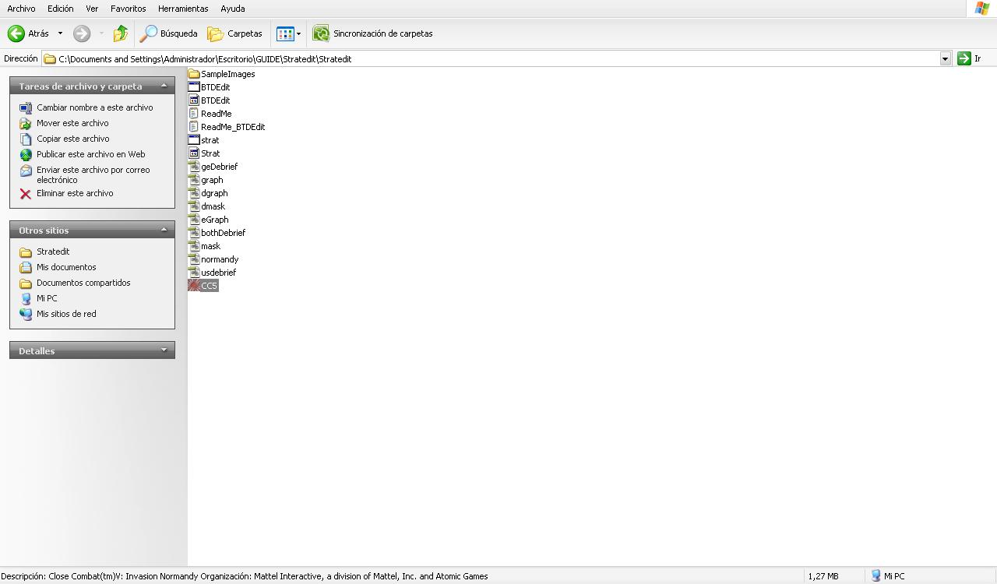
In this GUIDE i am going to make a small new stratmap with 3 areas, It will serve to learn the main aspects of how the tool works.
I am going to work with Last Stand Arhem(LSA).
My idea is based on the LA DRANG BATTLE.
Extract the CCIMAGES.PIX and create a new image called EGRAPH.TGA in format 16 BITS. Here is the final result…
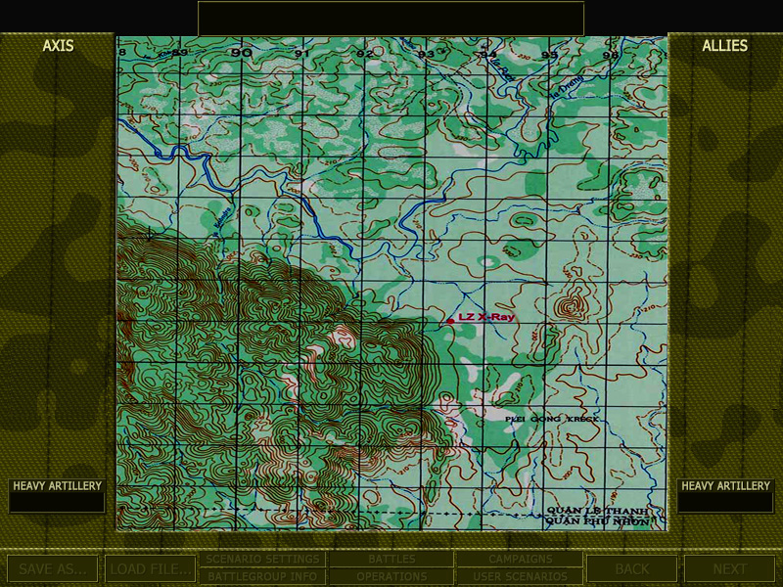

Now I am going to make my new stratmap…. first outline the areas of fighting:
Left area: CHU PONG, Top Right: LZ ALBANY and Lower Right: LZ X-RAY.
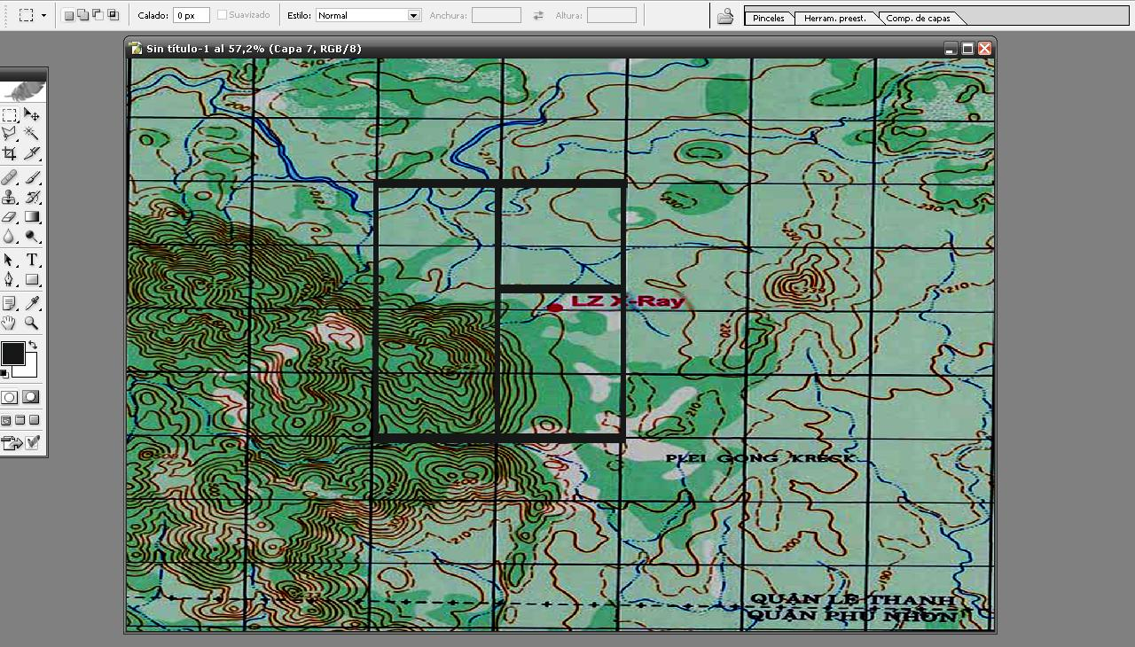

Now save this image as GRAPH.TGA (16BIT).
Also save this image as NORMANDY.TGA 16 BITS.
Now i am going to make a mask for the statmap, you must make 3 areas with different colors. (Every area must have its own distinct color)
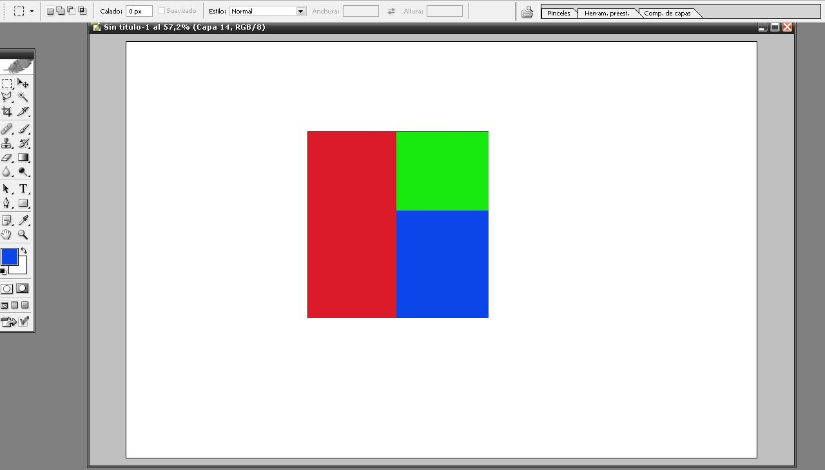
Paint the out of bounds areas of the strategic map all white.
The areas of combat (Mapareas) with contrasting colors.
Save this image as MASK.TGA
RESIZE the mask in 559x348 and save as DMASK.TGA and save in 16 bits.
Resize the stratmap image(1708x1129) to 559x348 and save the image as DGRAPH.TGA.
Now make the US and GE DEBRIEF.tga’s (560x348).
My style is to make the same image of stratmap for usdebrief,gedebrief and bothdebrief and then place the national symbols for each nation like the Berlin mod.

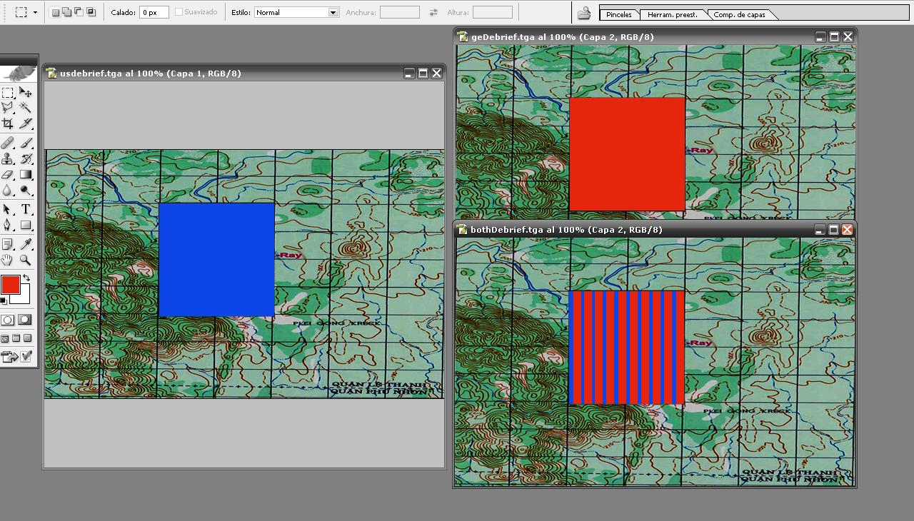

RUN the STRATOOL!!
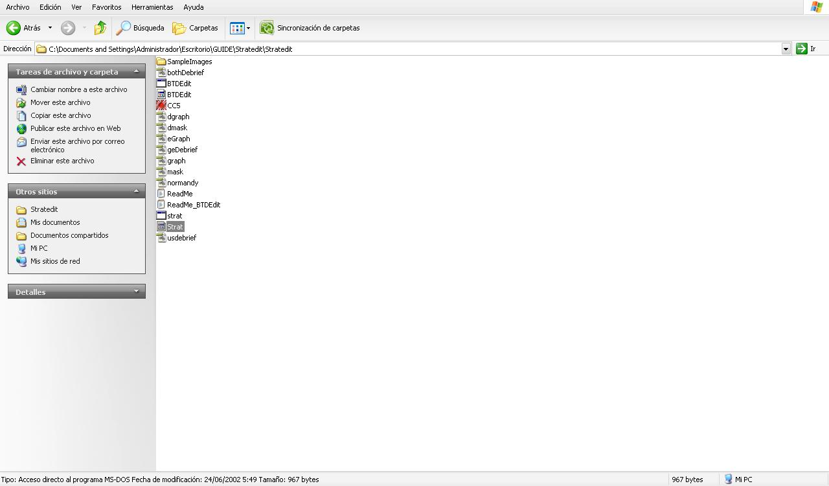

You will see this:……………………

Choose OPEN and the tool run your NEW STRATMAP;)
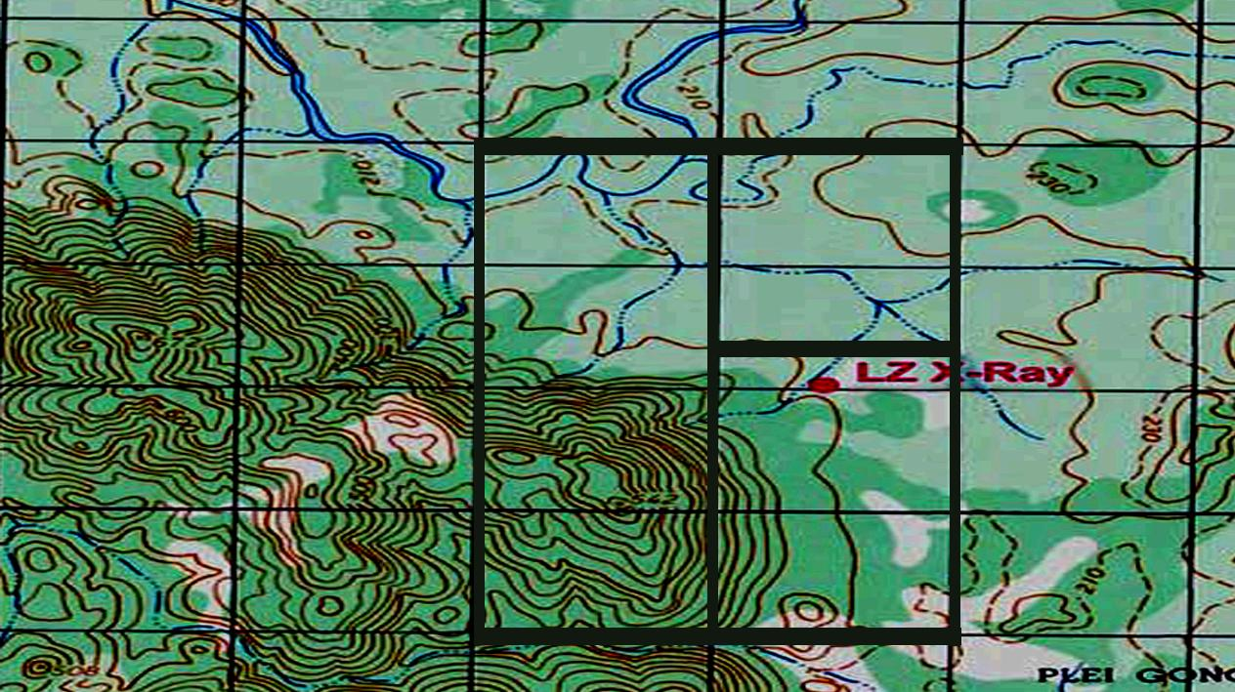

Select your AREAS of Combat (map areas) and select your connections….
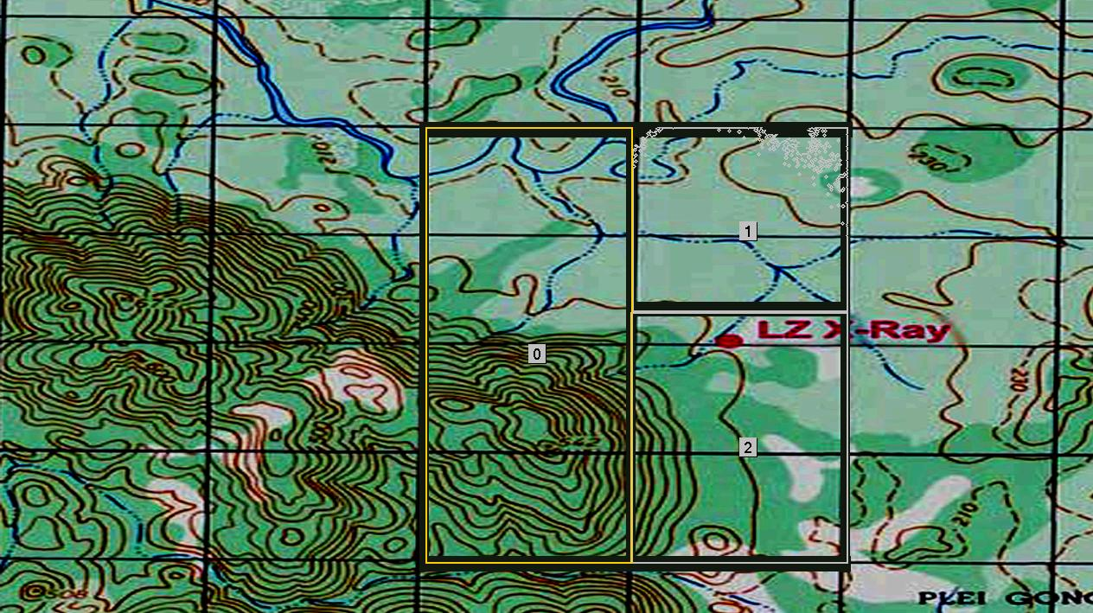
Now connections…ATTENTION
Note down what arrows belong to what map connection - from what map it starts and ends. This information will be placed in STRATMAP.TXT
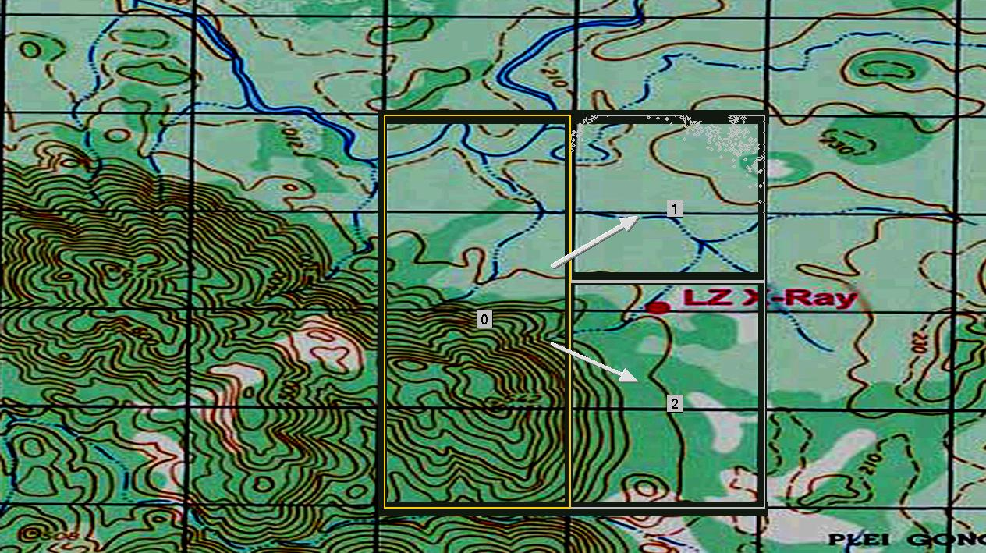

Now CLICK in VIEW/SCENARIOEDITOR MAP to place the SCENARIOEDITOR DIAMONDS in correct ORDER.
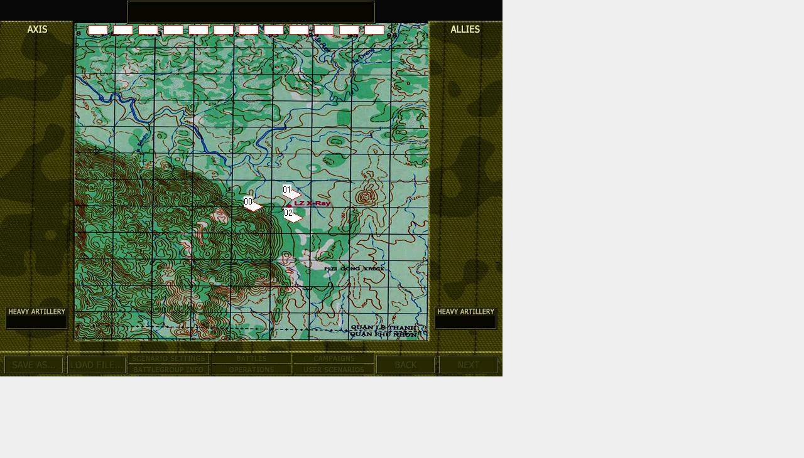

Now CLICK in VIEW/DEBRIEF MAP and SELECT AREAS of COMBAT.

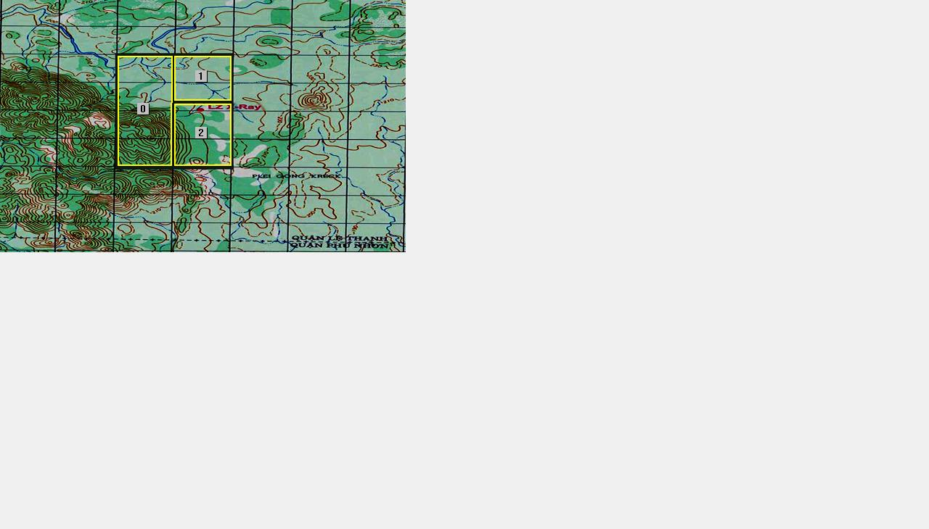

Now CLICK in EDIT/EXPORT TEXT and save the document in the folder STRATEDIT, this document contains all coordinates and connections for each map and you can open it with NOTEPAD.
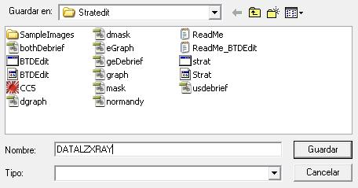

Finally SAVE and SAVE DATA.
Now STRATOOL has created all the graphics files that we need to be replaced in the SCRNGADG.GDG file.
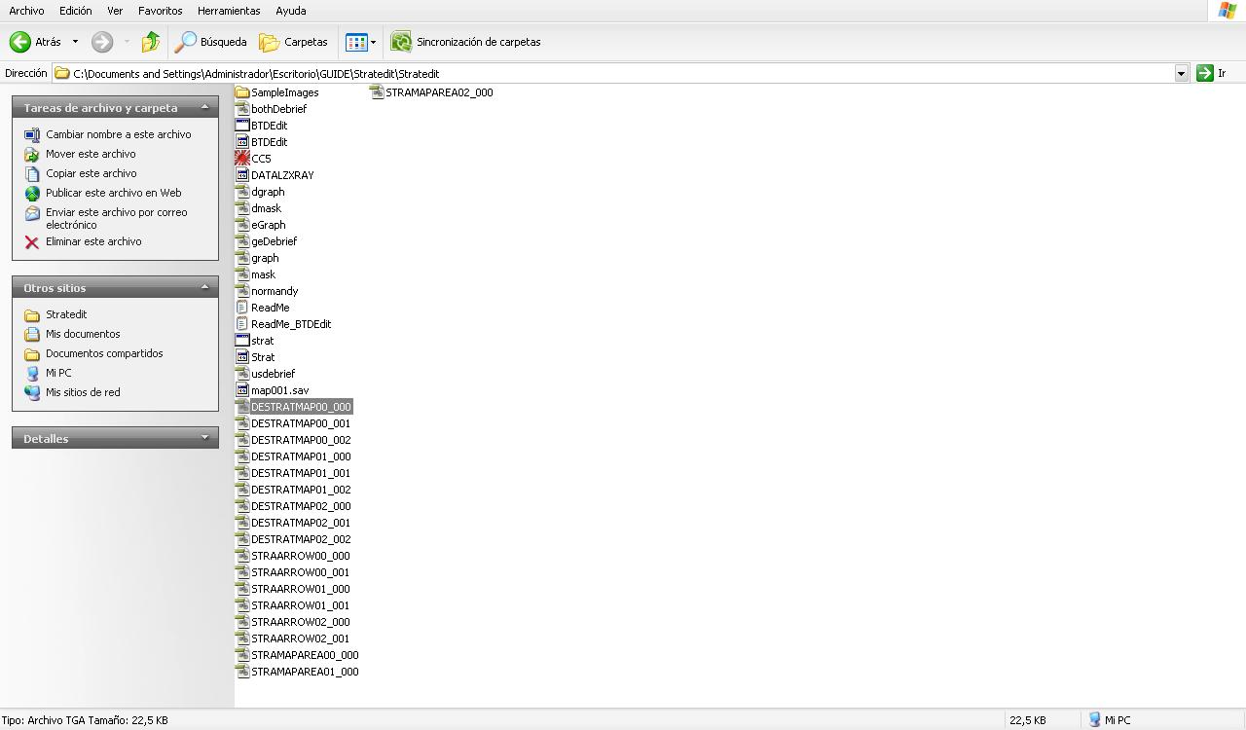

Put in the coordinates correctly in the STRATMAP.TXT of LSA.
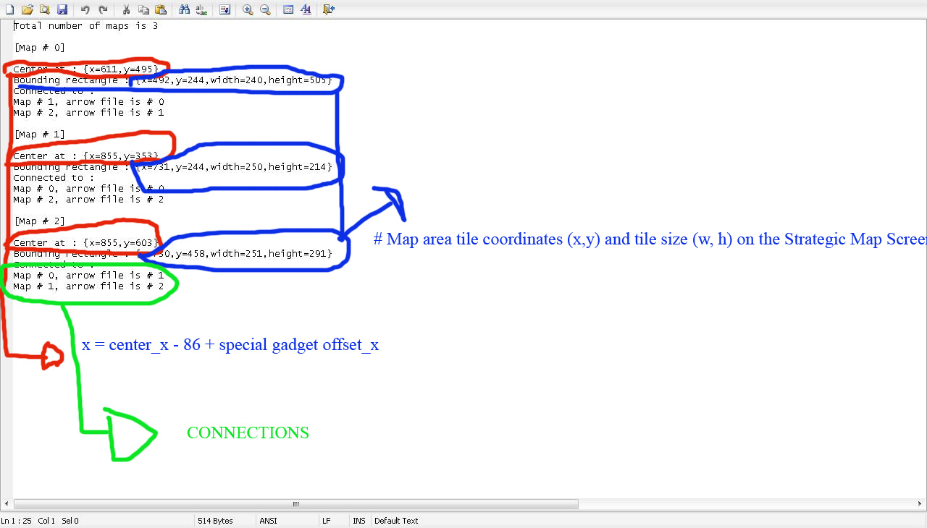
Now put in the coordinates of the NEW ARROWS :
Open RTBTool and select..SCREEN PATCH .EXE
Change the CC Version to CC5.exe and choose LOAD PROGRAM FILE and SELECT the CC5.exe from the stratedit folder.
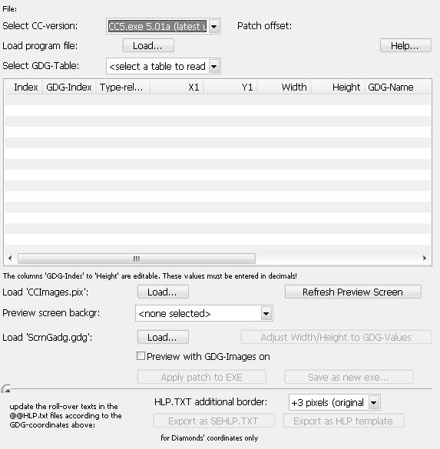

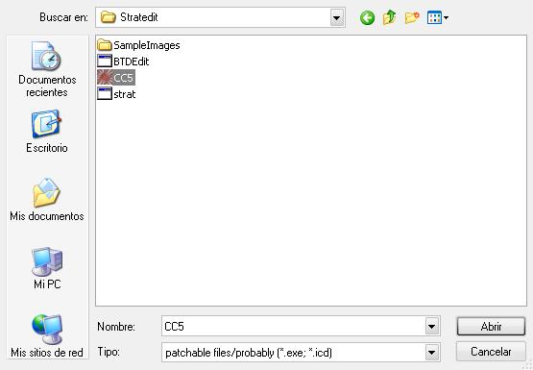

Now in SELECT GDG TABLE put ARROWS ON STRATEGIC 1 BIG SCREEN.
We have 6 new arrows so it will be six new coordinates.
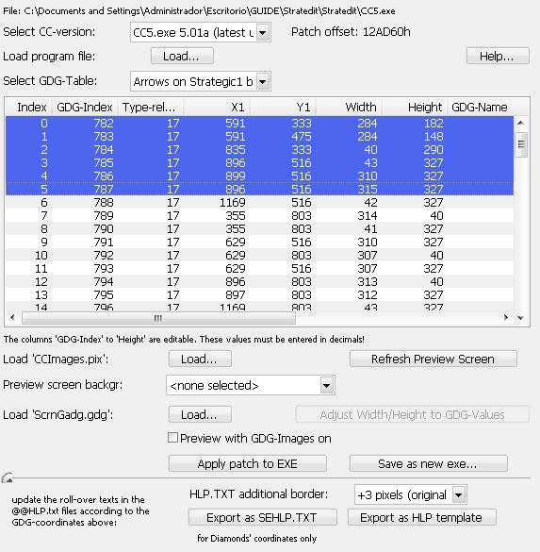
Put these coordinates in…# Coordinates (x,y,width,height) for the strat map screen for each arrow gadget on STRATMAP.TXT
Now change the SELECT GDG TABLE to DIAMONDS TABLE and put the coordinates
In …# SEMAP coordinates on the Scenario Editor screen (x,y,w,h) for each map on STATMAP.TXT
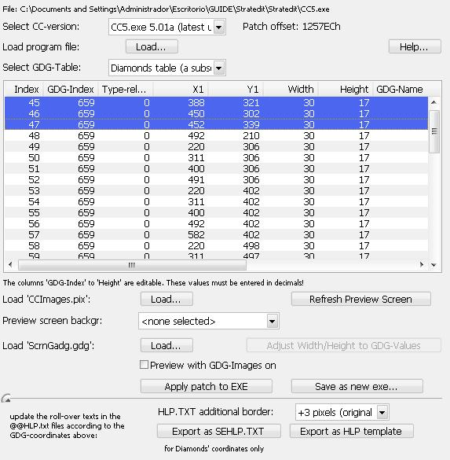

Now Change the SELECT GDG TABLE to DEBRIEF STRATMAP and put the new coordinates to # Debrief screen map gadget locations, one per map
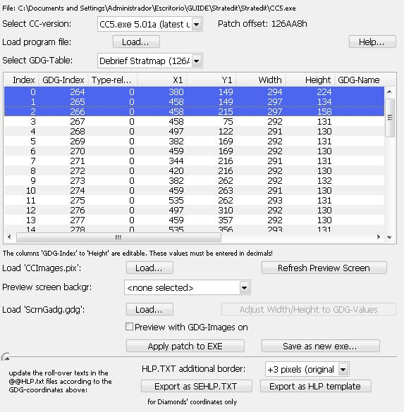
ATTENTION…If you want to create the RED CIRCLES you must copy all folder STRATEDIT not to disrupt the original and resize the MASK.TGS and GRAPH.TGA to 275X171 and save as 16 bit .tga
Run stratool and OPEN and select the areas and EDIT/EXPORT TEXT and you will get the coordinates for the red circles.

Please if you are able to create a new strategic map with this method would be happy to know, I would be very happy..ENJOY!!!!
Ahhhh I forgot….SORRY for my English;)

Edited language: Schnellemeyer

