How to easily convert a "standard" LSA/TLD/WAR CC map to Gateway to Caen or Panthers in the fog.
(And from GTC/PITF to "Standard")
1. Download 5CC (newest version as of writing is v1.22)
2. We will work on a copy so - Copy the map you want to modify to a separate folder. In our example it’s the "Afghanvillage2" map (From CCMT).
3. Open Afghanvillage2.txt , change the top line from 10 to 16 and save.
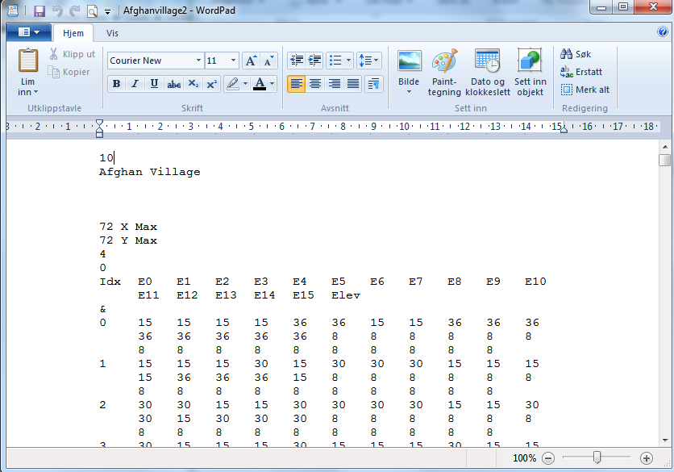
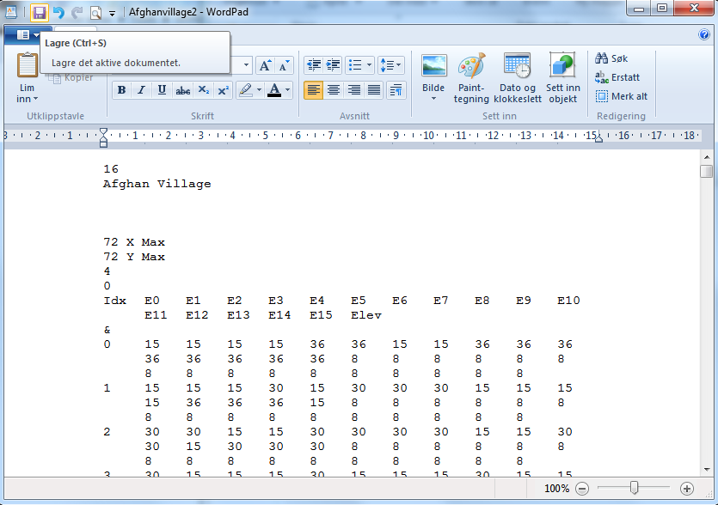
4. Open 5CC and open Afghanvillage2. - Pay attention to the pop-up box and note down the dimensions 5CC expected.
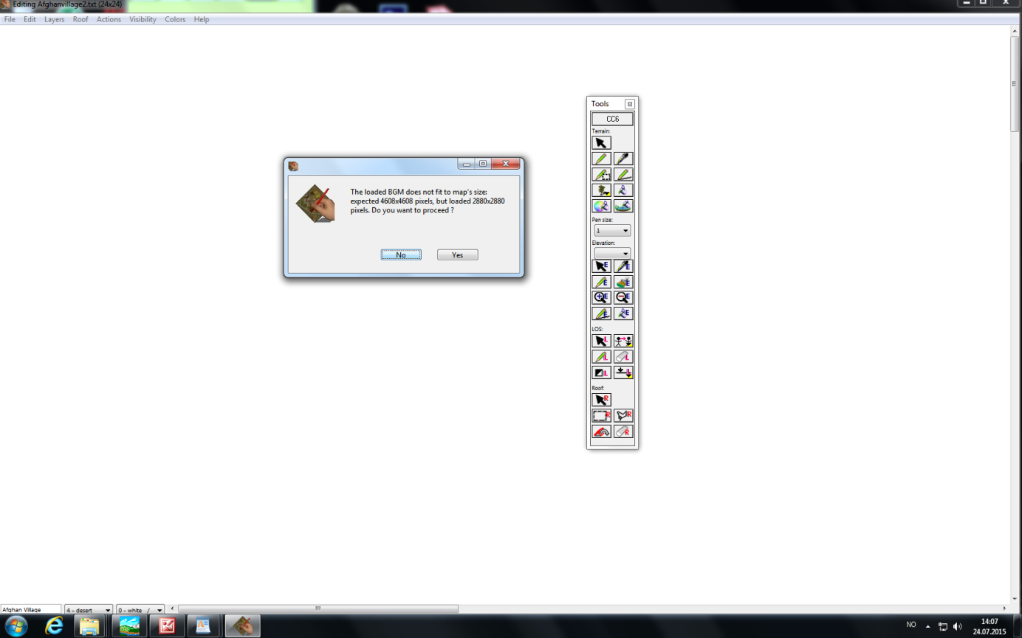
5. Click "No". - You do not want to proceed.
6. Open Afghanvillage2.txt, change the 16 back to 10 (Reversing step 3) and save.
7. Open 5CC and Afghanvillage2 again. Go to Actions - Set scale - Graphics scaling.
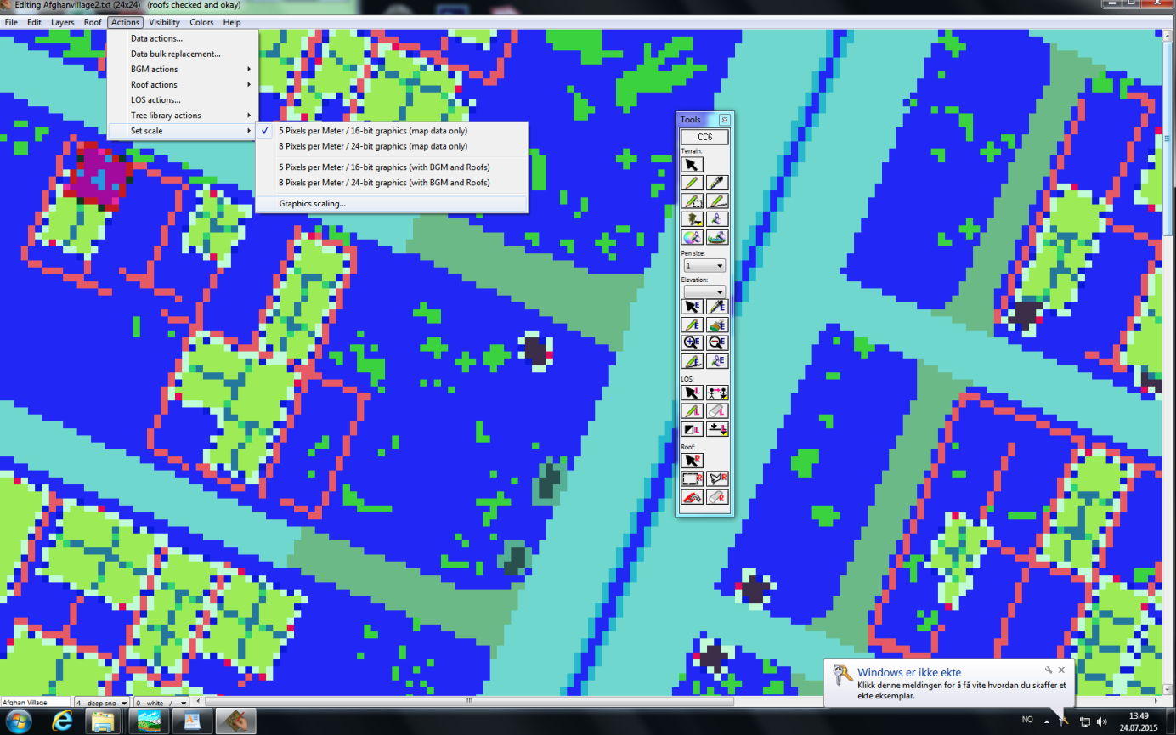
8. Plot in the dimensions you noted down in step 4 and click scale.
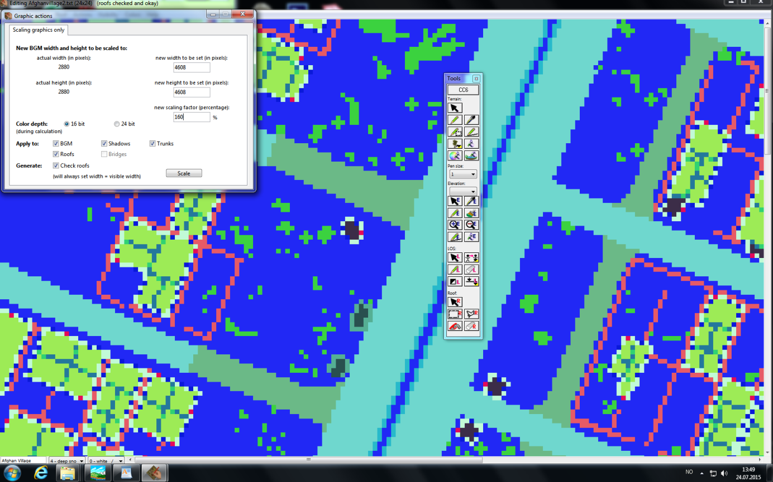
9. A roof warning could pop up during scaling. - Click cancel this.
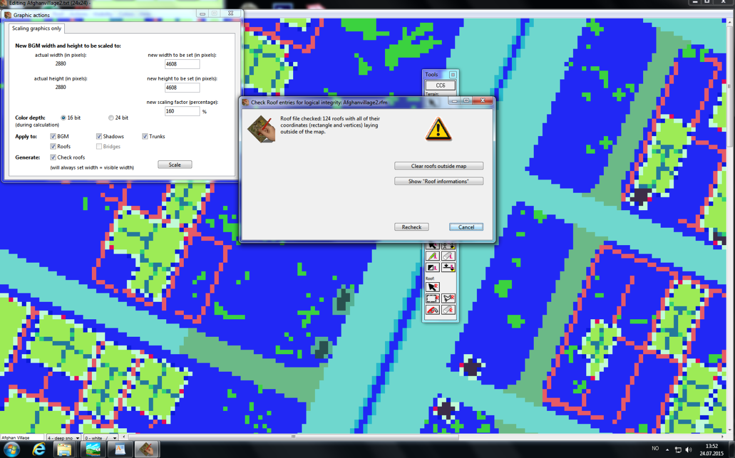
10. Go to Actions - Set scale : Change this from 5 to 8 pixels pr.meter.
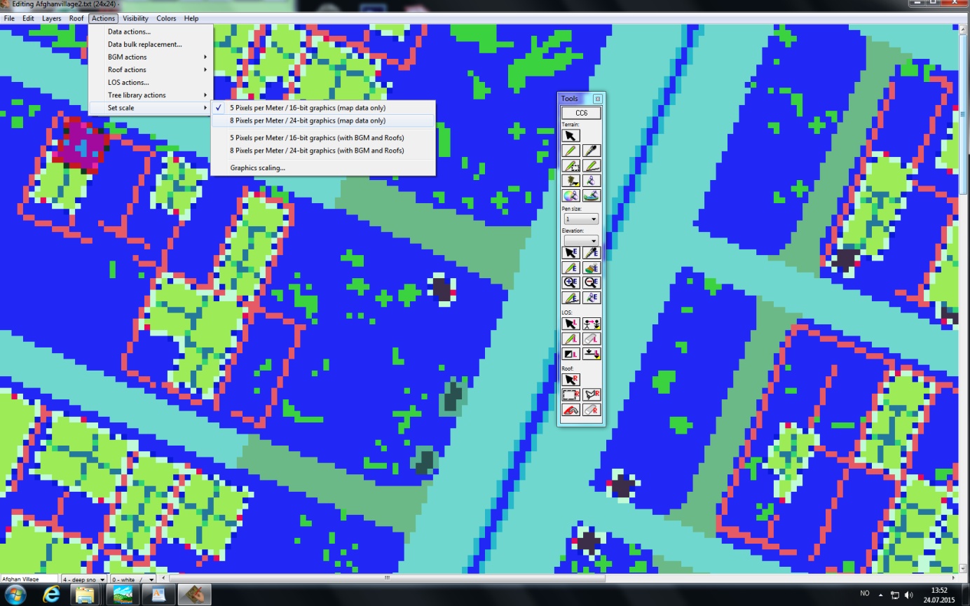
11. Save your map to a new folder.
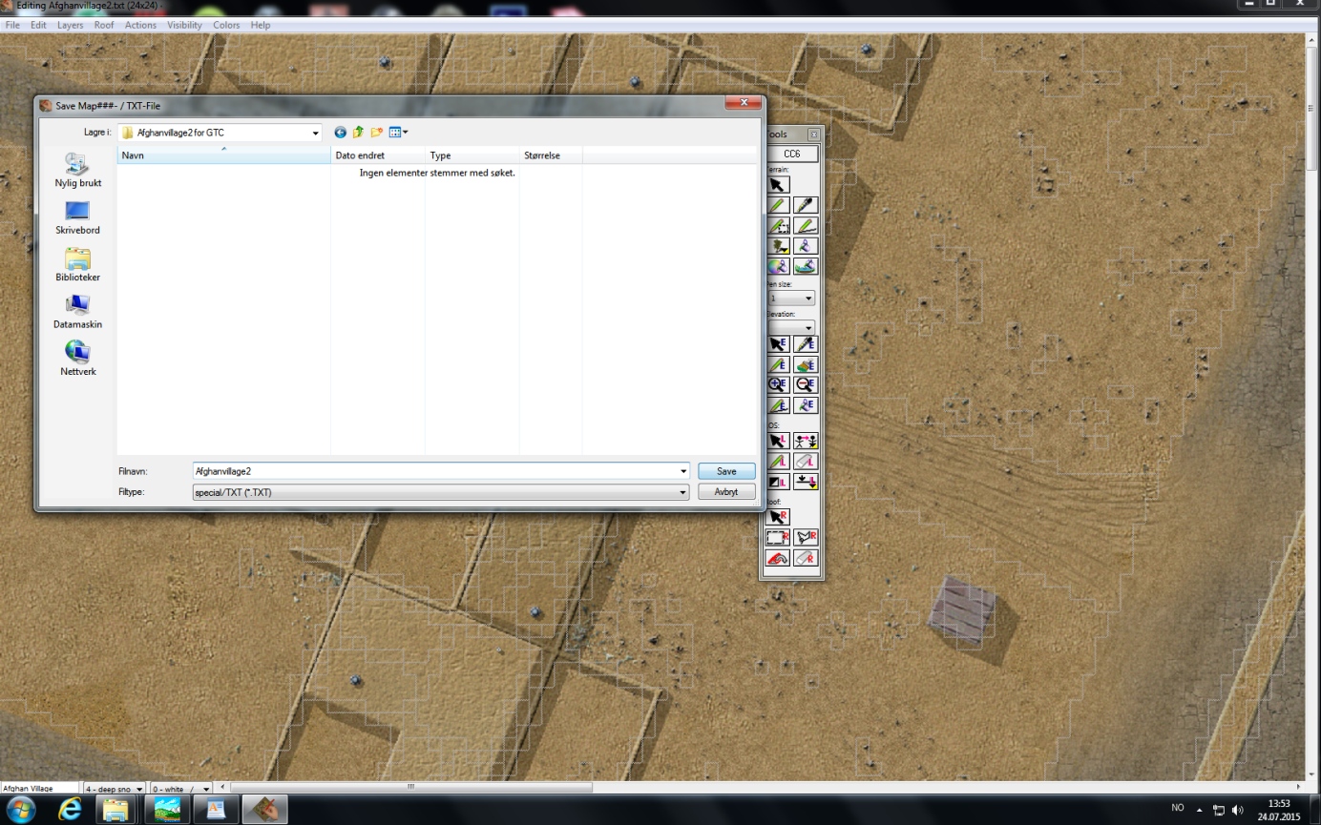
12. For a quick test: Put it in the map folder of your game, backup original map00 and rename your new scaled map to Map00. (Use the Original. BTD file)
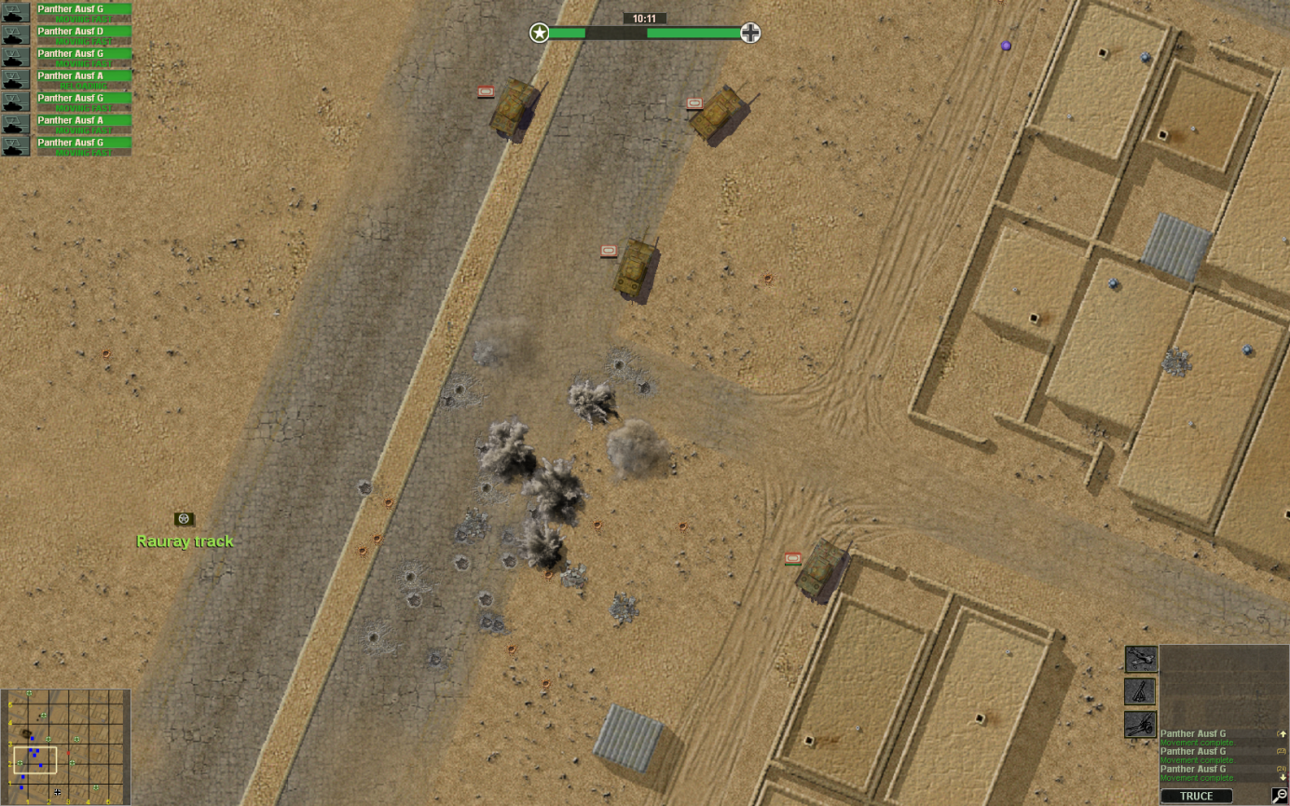
For a quick test: Put it in the map folder of your game, backup original map00 and rename your new scaled map to Map00. (You can use the Original .BTD file – Just make sure that the map you have modded are smaller than the original Map00.)
Good luck scaling any of the hundreds of Close combat maps available online.
Tutorial by: SchnelleMeyer.

